RULES OF PUBLICATION IN THE JOURNAL
“PHYSICAL TRAINING AND SPORTS TRAINING”

The scientific and methodological journal “Physical Education and Sports Training” publishes original articles reflecting the results of theoretical and experimental research in the field of physical education and sports.
The main sections of the journal:
- Theory and methods of physical education and sports training
- Issues of adaptive physical education
- Medical and biological aspects of physical education and sports training
- Psychological and pedagogical aspects of physical education and sports training
- Management in the field of physical education and sports
- Issues of vocational education in the field of physical education and sports
- Giving the floor to young researchers

Schedule of publication of the scientific and methodical journal “FEandST” and
deadlines for submitting articles to the editors for publication:
№ 1 (publication – March) – until March 1;
№ 2 (publication – June) – until June 1;
№ 3 (publication – October) – until October 1;
№ 4 (publication – December) – until December 1.

- Previously unpublished articles are taken into consideration in the directions of the presented sections in Russian or English. The article submitted for publication must be relevant, have a novelty, contain a goal, objectives, a description of the main research results obtained by the author, conclusions.
- The editors reserve the right to reduce and edit accepted works!

- Requirements for manuscripts sent to the journal

  - Registration and submission of articles:
- the text of the article should be carefully read;
- typed: line spacing – 1.5; font – 12 Times New Roman; all fields – 2.5 cm; paragraph indent (red line) – 1.27; all pages must be numbered; The function “automatic hyphenation” must be enabled;
- at the end of the article make out information about the authors;
- the text of the article is submitted in the format of Microsoft Office Word 2003, 2007;
- manuscript size, taking into account tables, illustrations, bibliography, no more than 10 pages; larger articles are printed only in agreement with the editorial board.

  - Article language
Manuscripts in Russian and / or English are accepted for publication in the journal. If the article is written in Russian, then an English translation is required (full name of the authors, the official name of the authors ’institutions, addresses, title of the article, abstract of the article, keywords, information for contacting the responsible author, as well as reference bibliography (References)). The translation (in the abstract) must be made taking into account the special terms used in the English-language literature and the transliteration rules of the authors' surnames into English. Articles of foreign authors in English can be published by decision of the chief editor of the journal without translation into Russian (with the exception of the name, full name of authors, summaries and keywords).

  - Title page:
The title page should begin with the following information:
- the title of the article;
- Surname, initials of the author (s);
- The full name of the institution (in Russian) in which each author works (in the nominative case) with the obligatory indication of the status of the organization, city, country.
This block of information should be presented in both Russian and English. The authors' names are recommended to be transliterated in the same way as in previous publications or on the BGN (Board of Geographic Names) system, see the website http://www.transliteration-online.ru/. With regard to the organization (s), it is important that the officially accepted English version of the name.
Example:

ВЛИЯНИЕ ПРИМЕНЕНИЯ ДОПИНГ-ПРЕПАРАТОВ НА ПРОЦЕСС
ПОСТ-ПРОФЕССИОНАЛЬНОЙ АДАПТАЦИИ ЭКС-СПОРТСМЕНОВ

Федотова И.В., кандидат медицинских наук, доцент
Таможникова И.С., кандидат медицинских наук
Волгоградская государственная академия физической культуры, г. Волгоград

THE DELAYED EFFECTS OF PERFORMANCE-ENHANCING DRUG USE
ON THE ADAPTATION OF RETIRED PROFESSIONAL ATHLETES

Fedotova I.V., Ph.D. in Medical Sciences, Associate Professor
Tamozhnikova I.S., Ph.D.in Medical Sciences
Volgograd State Physical Education Academy, Volgograd

РОЛЬ ГУМАНИСТИЧЕСКОЙ ПСИХОЛОГИИ
В ФИЗКУЛЬТУРНОМ ОБРАЗОВАНИИ

Геращенко Н.В., кандидат педагогических наук
Волгоградская государственная академия физической культуры, г. Волгоград
Геращенко И.Г., доктор философских наук, профессор
Волгоградский кооперативный институт (филиал) Российского университета кооперации, г. Волгоград

THE ROLE OF HUMANITARIAN PSYCHOLOGY IN PHYSICAL EDUCATION

Gerashchenko N.V., Ph.D. in Pedagogic Sciences, Associate Professor
Volgograd State Physical Education Academy, Volgograd
Gerashchenko I.G., Grand PhD in Sciences (Philosophy), Professor
Volgograd Cooperative Institute (branch) of the Russian University of Cooperation, Volgograd

  - Abstract (author’s summary) and keywords
Abstract of the article is the main source of information in domestic and foreign information systems and databases, indexing the magazine.
According to the summary of the article, the reader should be clear the essence of the study. According to the abstract, the reader must determine whether it is worth referring to the full text of the article for more detailed, interesting information. The summary should state only the essential facts of the work. For original articles, the structure of annotations is welcome, including: introduction, goals and objectives of the study, methods, results, conclusion (s). The purpose of the work is indicated in the event that it does not repeat the title of the article. The presentation of the methods should be brief and give an idea of ​​the research methodology. The results of the work describe extremely accurately and informatively. The main theoretical and experimental results, new scientific facts, detected relationships and patterns are presented. The information contained in the title of the article should not be repeated in the text of the abstract. It is necessary to avoid unnecessary introductory phrases (for example, “the article deals with ...”). Translation of annotations into English should be original (do not be tracing paper Russian-language annotations).
The abstract should be accompanied by keywords or phrases that reflect the main theme of the article and facilitate the classification of work in information retrieval systems. Keywords are listed separated by commas. At the end of the listing put a point. Abstract and keywords should be presented in both Russian and English.
Example:

В статье представлены результаты педагогических наблюдений за психофизическим состоянием детей 5-12 лет с синдромом Дауна в процессе их занятий адаптивной физической культурой в научно-практическом центре «Без границ» ФГБОУ ВО «ВГАФК». На основании внедрения и адаптации программы для дошкольников «Сказочный театр ритмической гимнастики» даются организационно-методические рекомендации по проведению занятий сюжетно-ролевой ритмической гимнастикой с особенными детьми. Практические рекомендации помогут корректировать педагогический процесс, вносить изменения в его содержание.
Ключевые слова: сюжетно-ролевая ритмическая гимнастика, дети с синдромом Дауна, адаптивная физическая культура.

ABSTRACT
The article presents the results of pedagogical observation of psychophysical state of children aged 5 to12 with Down syndrome during adapted physical education classes offered in Without Borders scientific and practical center under Volgograd State Physical Education Academy. On the basis of adapted Fabulous Theater of Rhythmic Gymnastics program for preschoolers, the author provides organizational and teaching recommendations for conducting gym classes based on storyline role play for children with special needs. The practical 53 recommendations will help improve teaching process and make appropriate modifications in its content.
Keywords: rhythmic gymnastics based on storyline role play; children with Down syndrome; adapted physical education.

  - Requirements for figures and tables
Tables and figures are located in the text of the article. References to them are given at each mention in parentheses (for example, (table 1), (figure 1)). All figures, tables, diagrams, photos in the article should be numbered (continuous numbering), have signatures (title, symbols). References to them in the text are required.
Requirements for the design of drawings:
- Figures are made in graphic editors and are presented in the form of graphic files in * .jpg format with a resolution of 600x600 dpi.
- Picture and title (caption) are aligned in the middle of the sheet.
- The title of the picture is made under the picture.
- The title is written in normal font (without italics and underscores).
- Headings of figures, as well as tables, begin with the denoting words and the sequence number of the figure in the article (according to the number).
All illustrations are accompanied by figure captions, including the number, name of the illustration and, if necessary, symbols. Abbreviations of words in the drawings are not allowed.
Example:

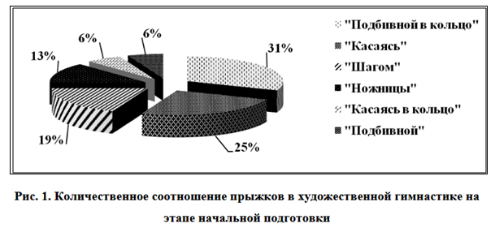

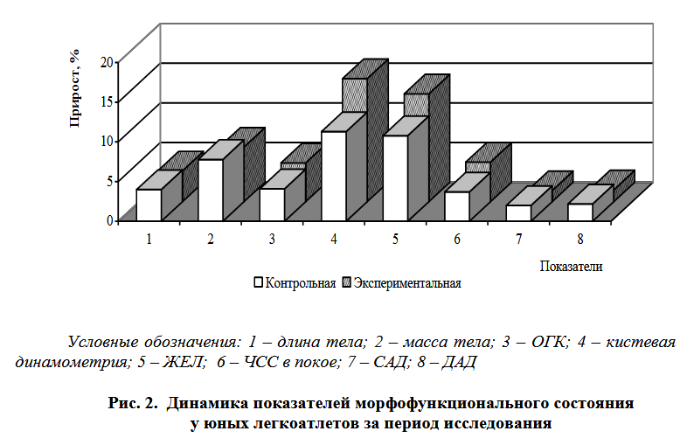
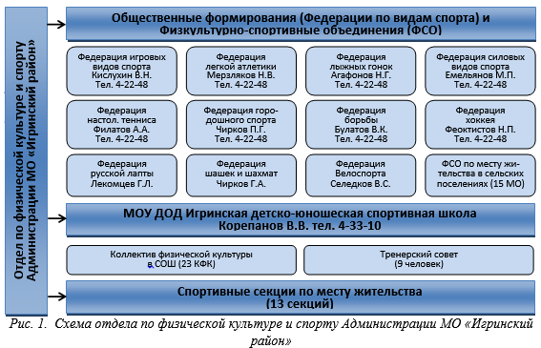
Рис.3. Схема отдела по физической культуре Администрации
МО «Игринский район»

Table Design Requirements:
- Each table (no more than 3) should be supplied with a serial number and heading: from the top right, write the word “Table” in ordinary font and designate the table number (if there are more than one table), its center is given below (in Russian).
- The heading of the tables should reflect its main content.
- All columns in the table should have headings with a capital letter, ordinary font or italics. Boldface type is allowed only when using a regular font.
- Abbreviations of words in the table are not allowed. Tables are vertically oriented. When designing tables and figures, the font size can be reduced to 12 points (a smaller font cannot be used) and a single line spacing. Large tables should be placed in the text on a separate sheet.
- All numbers in the tables should correspond to the numbers in the text. Decimals are commas (for example: 3.25; 0.5). In the columns of tables should not be voids or unexplained dashes.
- All tables in the text must be referenced (mention of them, and the table should go either immediately, or on the next sheet, or in the appendix to avoid confusion).
Example:
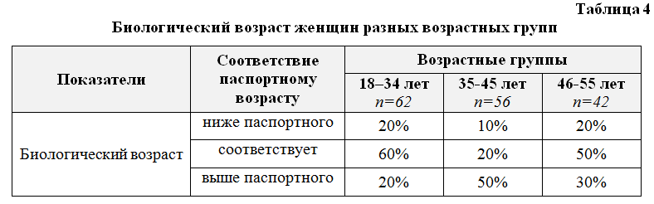
  - Formula Requirements
Mathematical equations should be presented as editable text, and not as images:
- The font of the text in the formulas must match the font of the main text.
- You cannot make out the formulas according to GOST in the built-in formula editor of Microsoft Word 2007 and above. For a set of complex multi-line formulas use Microsoft Equation or MathType.
- Explanations of the symbols, if they are not deciphered in the preceding text, are given directly under the formula. The definition of each symbol is given in the sequence in which they stand in the formula. The top line of explanation begins with the word where. And the colomn after it is not put.
- Formulas that follow one another and are not separated by text should be separated by commas.
- Formulas are numbered consecutively with Arabic numerals, which are fixed in parentheses to the right at the edge of the text: (1).
- In the text, references to formulas are given in brackets by their serial numbers.

Example:
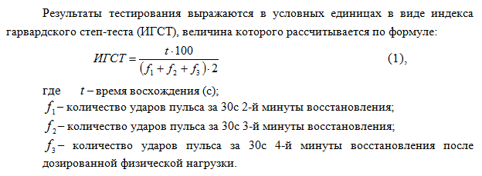
  - Bibliographic lists and references
Bibliographic list should be placed at the end of the text part of the manuscript. In the list of references all works are listed in alphabetical order. Bibliographic references in the text of the article indicate the number in square brackets. If there are several sources, then the link is made as follows: [1, 3, 5–9, 25].
- Links to unpublished works, dissertations are not allowed!
The correct description of the sources used in the reference lists is a guarantee that the cited publication will be taken into account when evaluating the scientific activities of its authors and the organizations that they represent. References made out according to GOST 7.0.5-2008.
In original articles, it is advisable to quote at least 20 sources, in literature reviews - no more than 60, in other materials – up to 15. The bibliography should contain fundamental works, publications over the past 5 years (at least 50%). Documents (Orders, State Standards, Health Regulations, Guidelines, Regulations, Ordinances, Sanitary and Epidemiological Rules, Regulations, Federal Laws) should be indicated not in the list of references, but in the text as a note.
- Self-citation is unacceptable, unless it is necessary (in the literature review, no more than 1-2 references).
Do not refer to dissertations and dissertation abstracts; it is more correct to refer to articles published based on dissertation research materials.

Examples of the list of references:
Books, monographs, textbooks, teaching aids
Ilyin E.P. Differential psychophysiology of men and women. – SPb.: Peter, 2002. – 123 p.
Pivneva M.M., Rumba O.G. Improving aerobics in the physical education of students with disabilities of the cardiovascular system: a monograph. – Belgorod: Belgorod Publishing House of BelSU National Research University, 2013. – 188 p.
Theory and methods of football: a textbook / under total. ed. V.P. Lips, A.V. Lexakov. – M .: Soviet Sport, 2013. – 536 p.
Solomchenko M.A. Economics of Physical Education and Sports: textbook / hl. ed. S.Y. Makhov. – Orel: MABIV, 2012. – 124 p.

Journal articles
One author
Gorskaya G.B. The development of subjective personality traits in the conditions of sports activity // Theory and practice of physical culture. – 2004. – № 8. – p. 47-49.
Two authors
Khrushchev S.V., Sobolev T.S. A new look at the old problems of women’s sports // Theory and practice of physical education. – 1996. – № 2. – p. 56-57.
Three authors
Vinogradov G.P., Grigoriev V.I., Vinogradov I.G. Foresight of educational standards in physical education // Uchenye zapiski universiteta imeni PF. Lesgaft – 2017. – № 6 (148). – p. 39.
Four authors (and more)
Pedagogical design of materials of distance courses for universities of physical education / Ilyasova A.Yu. et al. // Physical education: education, education, training. – 2017. – № 3. – p. 61-63.
Articles from electronic journals
Konovets L.N., Bezrukova NP, Lopatina T.N. Information educational resources for the system of advanced training and retraining of nurses // Modern problems of science and education. – 2018. – № 4; URL: http://www.science-education.ru/ru/article/view?id=27861 (request date: hh.mm.yyyyy).

Abstract of thesis and dissertation
Kalinina I.F. An integrated approach to the conduct of classes of aerobics and recreation with female students of higher educational institutions: author. dis. ... Cand. ped. sciences. – M., 2007. – 24 p.
Belikova Z.A. Hatha yoga exercises as a means of correcting spinal deformity for students of special medical groups with impaired posture: dis. ... Cand. ped. sciences. – Belgorod, 2012. – 172 p.

Conference proceedings
Bosenko A.I., Maslovsky E.A., Yakovlev A.N. Organization and management of institutions providing health and fitness services // Health saving technologies and systems: psychological, pedagogical and biomedical aspects: materials of the II International Scientific and Practical Conference (Baranovichi, May 12-13, 2016) / ed. A.V. Nikishov [et al.]. – Baranovichi: BarSU, 2016. – P.125-131.
Yakovlev A.N. Efficiency of physical education and sports activities // Optimization of the educational process in educational institutions of physical education: materials of the XXIII Regional Scientific and Practical Conference with international participation, May 24, 2013 – Chelyabinsk: UralGUFK, 2013. – p. 244-245.

Internet resources
The concept of the federal target program “Development of physical education and sports in the Russian Federation for 2016-2020” [Electronic resource]: the order of the Government of the Russian Federation of January 2, 2014 No. 2 – R. – Access mode: http://static.government.ru/media/files/41d4b1a00210c7effc66.pdf

  - Transliteration of references (References)
Taking into account the requirements of international citation systems, bibliographic lists are included in the English-language block of the article and, accordingly, should be given not only in the original language, but also in the Latin alphabet (Romanesque alphabet). Therefore, the authors should give a list of references in two versions: one in the original language (Russian-speaking sources in Cyrillic, English-speaking Latin), and a separate block of the same reference list (References) in the Romanesque alphabet for international databases, repeating in it all sources of literature, independently whether they are foreign. If the list contains references to foreign publications, they are completely repeated in the list that is being prepared in the Romanesque alphabet.
Note: On the website http://www.transliteration-online.ru/ you can use the program for transliteration of the Russian text into the Latin alphabet for free. Transliteration is necessary for the correct and accurate transmission of Russian words by letters of the English alphabet.

